
SERANGOON JUNIOR COLLEGE
General Certificate of Education Advanced Level
Higher 1

CANDIDATE
NAME

CLASS INDEX NUMBER

CHEMISTRY 8872/02
Preliminary Examination 23 Aug 2010
Paper 2 2hr

Additional Materials: Data Booklet
Writing Papers

READ THESE INSTRUCTIONS FIRST

Write your name and class on all the work you hand in.
Write in dark blue or black pen on both sides of the paper.
You may use a soft pencil for any diagrams, graphs or rough work.

SECTION A:
Answer all questions in the space provided.

SECTION B:
Answer any two questions on separate answer paper.

At the end of the examination, fasten all your work securely together.
The number of marks is given in brackets [ ] at the end of each question or part question.
For Examiner’s Use
MCQ P1 | /30
A1 | /10
A2 | /10
A3 | /10
A4 | /10
Section B1 | /20
Section B2 | /20
Section B3 | /20
Total | / 110

This document consist of 16 printed pages and 0 blank page

Section A
Answer all the questions in this section in the spaces provided
1 | The simplest hydride of boron is boron hydride of molecular formula B₂H₆. It has been suggested that gaseous boron hydride can be used as a rocket propellant, using either oxygen or fluorine as oxidants.  Combustion of boron hydride with oxygen yields a high melting point solid boron (III) oxide, B₂O₃ and water as the only products.
 | (a) | (i) | Write the balanced chemical equation for the reaction between boron hydride and oxygen.
 |  |  | ………………………………………………………………………………………………….
 |  | (ii) | Using the information given below, calculate the standard enthalpy change for the above reaction.
  Substance | Standard enthalpy change of formation /  kJ mol⁻¹
  B₂O₃ | -1273
  B₂H₆ | +36
  H₂O | -286
 |  | (iii) | Using data from the Data Booklet and information below, identify the standard enthalpy terms ΔH^{ө}₁, ΔH^{ө}₂, ΔH^{ө}₃ and ΔH^{ө}₄ on the left hand side of the Born Haber Cycle.  ΔH^{ө}₁ is ………………………………………………………………………  ΔH^{ө}₂ is ……………………………………………………………………...  ΔH^{ө}₃ is ……………………………………………………………………..  ΔH^{ө}₄ is ……………………………………………………………………..  Hence determine the lattice energy of boron (III) oxide. | [5]
  2B³⁺ (g) + 3O (g) | + 6e
  2x ΔH^{ө}₆
  2B²⁺ (g) + 3O (g) + 4e |  | 3 x EA of oxygen
  2 x ΔH^{ө}₅
  2B⁺ (g) + 3O (g) + 2e |  | 2B³⁺ (g) + 3O²⁻ (g)
  2 x ΔH^{ө}₄
  2B (g) + 3O (g)
  3 x ΔH^{ө}₃ |  | ΔH^{ө}_{latt}
  2B (g) + 3/2 O₂ (g)
  2 x ΔH^{ө}₂
  2B (s) + 3/2 O₂ (g)
  ΔH^{ө}₁
  B₂O₃ (s)
  Enthalpy term | ΔH^{θ} / kJ mol⁻¹
  Standard enthalpy change of formation of boron (III) oxide | -1273
  Standard enthalpy change of atomisation of boron | +573
  Standard enthalpy change of atomisation of oxygen | +248
  Sum of first and second electron affinity for oxygen | +702
 | (b) |  | Paracetamol is a common analgesic and pyretic drug often used as a painkiller and for treating mild fever. In a study carried out to determine the rate of removal of paracetamol from the body, the reaction was found to have a constant half-life of 2.7 hours.  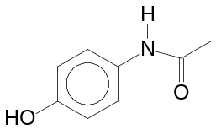  Paracetamol
 |  | (i) | Sketch a graph to show how 1 mol dm⁻³ of paracetamol decreases to 25% of its initial concentration.
 |  | (ii) | Write the rate equation for the reaction and calculate the value of the rate constant, k.
 |  |  | …………………………….…………………………………………………………………….
 |  | (iii) | Explain why Paracetamol is not very soluble in water. [5]
………………………………………………………………………………………………….
………………………………………………………………………………………………….

[Total: 10 marks]

2 |  |  | Alcohol B has the following structure:  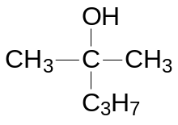
 | (a) |  | Draw the displayed formula of the possible isomers of alcohol B. Label your isomers for use in (b). [2]
 | (b) |  | To the corresponding isomers of alcohol B in (a), concentrated sulfuric acid was added and products with molecular formula, C₆H₁₂ were obtained. Draw the structural formula of the products formed. [2]
 | (c) |  | The boiling point of three organic compounds is given as follow:  Briefly explain the difference in their boiling point. [2]
  Compound | Boiling Point
  Butene | 273 K
  Butan-1-ol | 390 K
  Butanoic acid | 437 K
…………………………………………………………………………..................................

……………………………………………………………………………………………………

……………………………………………………………………………………………………

 | (d) |  | Organic compound C contains carbon, hydrogen and oxygen only.  10 cm³ of compound C undergoes complete combustion to produce 40 cm³ of carbon dioxide and 50 cm³ of water vapour. 1 mol of C produces 0.5 mol of hydrogen gas when sodium metal is added.  No effervescence was observed when compound C was reacted with sodium carbonate but white fumes of gas were seen when phosphorous pentachloride was added to compound C.  Upon reaction with acidified potassium manganate (VII), compound D was formed. Compound D reacts with 2,4-DNPH but did not react with Tollen’s reagent. Compound C and D both give yellow precipitate when reacted with alkaline aqueous iodine.  Compound C was passed through hot alumina and compound E was obtained as one of the products. When compound E undergoes strong oxidation, bubbles of gas were observed.  Draw the structures of Compound C, D and E. [4]

[Total: 10 marks]

 | 3 |  | Shikimic acid, is an important biochemical intermediate in plants and microorganisms.  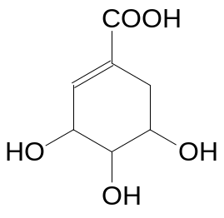  Shikimic acid
 | (a) |  | Draw the structural formulae of the organic products formed when shikimic acid is treated with HBr followed by hot aqueous NaOH. [2]
 | (b) |  | Apart from shikimic acids, cinnamic acid, zingerone and vanillin are other compounds that can be naturally isolated from plants and herbs.  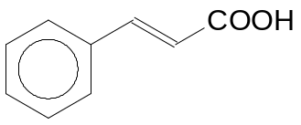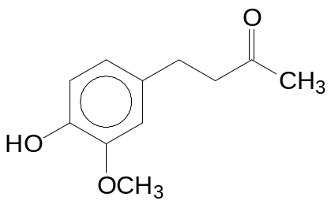  Cinnamic acid Zingerone  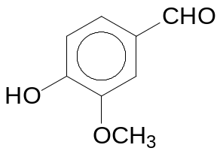 Vanillin  (for this question ignore the chemical effect of –OCH₃)
 |  | (i) | State one reagent and condition that will react with vanillin and not zingerone and describe what would be observed.  Reagent and condition: …………………………………………………………...  Observation: …………………………………………………..............................
 |  | (ii) | State one reagent and condition, other than Br₂ and oxidising agent, that will react with cinnamic acid and not zingerone and describe what would be observed. [4]  Reagent and condition: …………………………………………………………...  Observation: ……………………………………………………...........................
 | (c) |  | The carbonyl functional group undergoes a series of reactions which follow the following pattern:  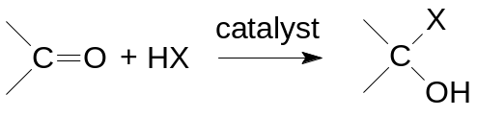  where X can be CN, OCH₃, etc.  Using the above information, draw the structural formula of the product formed for the following reactions:
 |  | (i) | Addition of HCN to 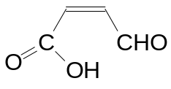, followed by a dehydration process.
 |  | (ii) | Addition of CH₃OH to vanillin, followed by an oxidation reaction. [2]  (Note: –OCH₃ is inert to oxidation)
 | (d) |  | Shikimic acid undergoes complete combustion to form carbon dioxide and water. Construct a reaction pathway diagram for the combustion process. In your diagram, clearly indicate the enthalpy change of combustion and activation energy. [2]

[Total: 10 marks]

4 | (a) | (i) | On the grid below, sketch the trend of the ionic radii of elements in Period 3 from sodium to chlorine.  ionic  radii / nm  Na Mg Al Si P S Cl  ement
  Element
 |  | (ii) | Explain the trend of the ionic radii for elements in Period 3. [3]  ........................................................................................................................  ........................................................................................................................  ........................................................................................................................  .......................................................................................................................  .......................................................................................................................

 | (b) |  | The first six ionisation energies of three successive elements in a Periodic Table are given below:
   | Ionisation Energy in kJ mol⁻¹
  Element | 1st | 2nd | 3rd | 4th | 5th | 6th
  F | 786 | 1580 | 3230 | 4360 | 16100 | 19800
  G | 1060 | 1900 | 2920 | 4960 | 6270 | 21300
  J | 1000 | 2260 | 3390 | 4540 | 7000 | 8500
 |  | (i) | State and explain the Group which element G belongs to.  Group: ..................................  Explanation: ..................................................................................................................  .......................................................................................................................................  ......................................................................................................................................
 |  | (ii) | Explain why the first ionisation energy of G is  higher than F:  .......................................................................................................................................  .......................................................................................................................................  and higher than J:  .......................................................................................................................................  .......................................................................................................................................
 |  | (iii) | Suggest a chemical formula of an oxide of element J and predict the type of bonding present in the oxide of J.  Formula of oxide of J: ..............................................  Type of bonding present in oxide of J: ......................................
 |  | (iv) | With aid of an equation, predict a pH value for the resulting solution obtained when the oxide of J is dissolved in water.  Equation: ....................................................................................  pH = ..................................... [7]
[Total: 10 marks]

Section B
Answer two questions from this section on a separate piece of paper.

5 | (a) | 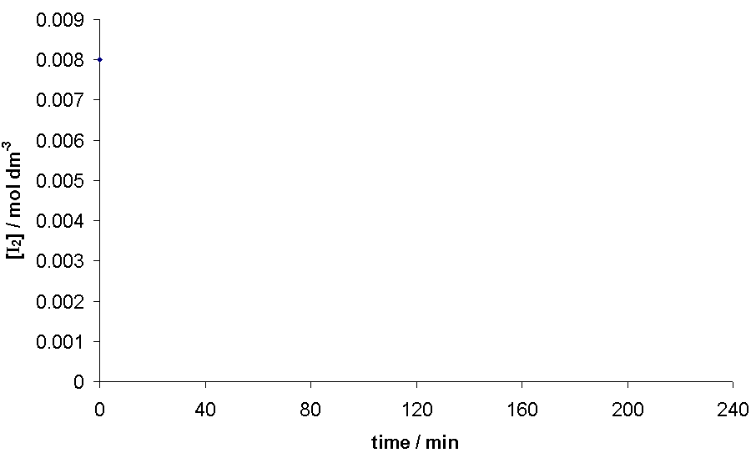  The kinetics of the acid–catalysed reaction of propanone with iodine can be investigated experimentally by varying the concentrations of the three substances involved.  [I₂] / mol dm^{–3}  [H⁺] = 0.20 mol dm^{–3}  [CH₃COCH₃] = 0.10 mol dm^{–3}  [H⁺] = 0.10 mol dm^{–3}  time / min  time / min  [H⁺] = 0.10 mol dm^{–3}  [CH₃COCH₃] = 0.10 mol dm^{–3}  [I₂] / mol dm^{–3}  [CH₃COCH₃] = 0.15 mol dm^{–3}  time / min  CH₃COCH₃(aq) + I₂(aq) CH₂ICOCH₃(aq) + HI(aq)  The following results were obtained in an experiment.
 |  | (i) | Deduce, with reasoning, the order of reaction with respect to (1) I₂, (2) H⁺ and (3) CH₃COCH₃.
 |  | (ii) | Hence, write a rate equation for the reaction and determine a value for the rate constant k, including its units.
 |  | (iii) | Predict, with reasoning, the effect of a catalyst on the activation energy and rate constant of a reaction. [10]
 | (b) | Propanoic acid and citric acid are some of the acids used in the formulation of hair shampoo. A chemistry student wanted to formulate a shampoo with maximum buffer capacity so that there will be minimal damage to the hair.  In an attempt to prepare a buffer for the shampoo, she titrated 20.0 cm³ of 0.100 mol dm⁻³ sodium hydroxide against 0.20 mol dm⁻³ citric acid.
 |  | (i) |  | Deduce, with reasoning, whether propanoic acid or 2-chloropropanoic acid is a stronger acid.
 |  | (ii) |  | Calculate the pH of 0.100 mol dm⁻³ sodium hydroxide.
 |  | (iii) |  | Calculate the volume of citric acid required to completely neutralise 20.0 cm³ of sodium hydroxide.
 |  | (iv) |  | When excess citric acid is added, a buffer solution is obtained.  Explain, with the aid of equations, how the mixture can act as a buffer upon addition of a small amount of acid and alkali.  (Citric acid could be represented by C₅H₇O₄COOH)
 |  | (v) |  | The pH of 1 mol dm⁻³ of propanoic acid is 4 while the pH of 1 mol dm⁻³ of hydrochloric acid is 1. Explain the difference in their pH.
 |  | (vi) |  | Suggest with reasoning, if the same volume of hydrogen gas will be produced if propanoic acid and hydrochloric acid, of the same concentration and volume are to react with 2.0 g of zinc metal under the same condition. [10]
[Total: 20 marks]

66 | (a) | Compound K has a composition of 46.15% C, 7.69% H and 46.15% O. It is formed when compound L (a bromo-containing organic substance) is refluxed with aqueous sodium hydroxide followed by acidification.  Effervescence was observed when sodium carbonate was added to K. Upon treatment of K with acidified potassium dichromate (VI), compound M is produced. Compound M reacts with 2,4-dinitrophenylhydrazine to form an orange hydrazone, N. On reaction of M with Fehling’s reagent, the reddish brown deposit was however not observed.  A yellow precipitate was observed when K and M were warmed with alkaline aqueous iodine. When K is refluxed with concentrated sulfuric acid, a sweet smelling compound P, C₈H₁₂O₄ is formed.  Deduce the structures of K, L, M, N and P. Maximum credit cannot be awarded just by drawing of the structures only. [10]
 | (b) | Suggest a simple chemical test to distinguish between the following compounds:  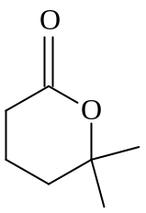and 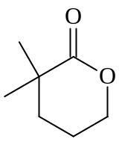 [3]
 | (c) | Antimony pentachloride (SbCl₅) decomposes in a gas phase reaction at high temperature.  SbCl₅ (g) ⇌ SbCl₃ (g) + Cl₂ (g) ΔH = negative  At some temperature, dynamic equilibrium is established. An equilibrium mixture in a 5 dm⁻³ container is found to contain 6.91 g of SbCl₅, 16.45 g of SbCl₃ and 5.11 g of Cl₂.
 |  | (i) | What is meant by the term dynamic equilibrium?
 |  | (ii) | Determine the K_{c} expression and hence calculate K_{c} for the above equilibrium.
 |  | (iii) | Using Le Chatelier’s Principle, state and explain the effect on the position of equilibrium and the equilibrium composition when:  - temperature is decreased at constant pressure,  - pressure is decreased at constant temperature. [7]
[Total: 20 marks]

7 | (a) | The oxides of sodium to phosphorus (Na₂O, MgO, Al₂O₃, SiO₂ and P₄O₁₀) differ in their bonding and reactions with water.
 |  | (i) |  | Copy and complete the following graph on your answer script.  pH  Na₂O MgO Al₂O₃ SiO₂ P₄O₁₀  You are to indicate clearly on your graph the pH of the resulting solution when each oxide reacts with water.
 |  | (ii) |  | With the aid of equations, state the pH of the solution obtained when aluminium chloride is dissolved in water.
 |  | (iii) |  | A student was instructed to perform tests to deduce the identities of two chemical bottles with missing labels. The bottles contain either gallium oxide or selenium oxide.  The student first labelled the two bottles as Q and R. Then, he conducted solubility tests and record his observations as follows:  Sample Q dissolves in both hydrochloric acid and aqueous sodium hydroxide while sample R dissolves in aqueous sodium hydroxide only.  Suggest the identities of Q and R and write equations to show the acid-base behaviour of the oxides. [8]  [Gallium is ₃₁Ga; Selenium is ₃₄Se]
 | (b) | Ethanol is a chemical which is widely used as a solvent, fuel and an important intermediate in large scale synthesis of organic compounds.  When 2.00 g of ethanol was burned under a container of water, the heat released was found to increase the temperature of 150 g of water from 28ºC to 65ºC.
 |  | (i) |  | Write a balanced equation, with state symbols, to represent the standard enthalpy change of combustion of ethanol.
 |  | (ii) |  | Using the data given above, calculate the enthalpy change of combustion of ethanol.
 |  | (iii) |  | Using bond energy values from the Data Booklet, calculate another value for the standard enthalpy change of combustion of ethanol. Suggest an explanation for the discrepancy between your answer and the calculated value in b(ii). [6]
 | (c) | Glycolic acid is the smallest α-Hydroxy acids (AHAs). It is also one of the main ingredients used in the manufacture of skin care products due to its excellent capability to penetrate human skin.  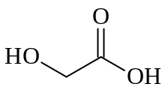  Glycolic Acid
 |  | (i) | Show how glycolic acid can be synthesized from methanol via three steps. In your answer, show clearly the reagents, conditions and intermediates involved.
 |  | (ii) | State the product(s) formed when hot acidified potassium manganate (VII) is added to glycolic acid.
 |  | (iii) | Explain, with the aid of a diagram, why the relative molecular mass of glycolic acid is 152 when dissolved in a suitable solvent. [6]
[Total: 20 marks]

END OF PAPER

